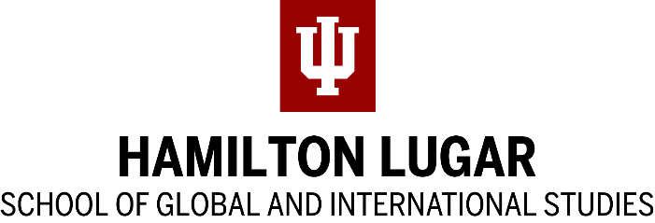

Title VIII Instructor Reference Instructions
The Department of State's Title VIII Program for Research and Training on Eastern Europe and the Independent States of the Former Soviet Union provides fellowships for graduate students, scholars, and researchers to study the languages of Eastern Europe and the former Soviet Union.
The program is funded because Congress has found that:
"... independently verified factual knowledge about the countries of Eastern Europe and Eurasia is critical to the national security of the United States, the furtherance of its national interests in the conduct of foreign relations, and the prudent management of its domestic affairs. [...] The development and maintenance of U.S. expertise on these regions depends upon a national capability for advanced research by highly trained specialists with in-country experience."

The mission of the Title VIII program is to: "guarantee the existence of that knowledge and the capability to sustain it," in part by providing language training and in-country experience for graduate students.

Title VIII Fellowships administered through the Indiana University Language Workshop support summer study of less-commonly-taught languages. The Workshop has a limited number of fellowships and admission is competitive.
For more information, see http://languageworkshop.indiana.edu.
Please upload your recommendation to the Language Workshop Upload Page or mail it to languageworkshop@indiana.edu NO LATER THAN MIDNIGHT EST, JANUARY 27, 2023.
Contact languageworkshop@indiana.edu for confirmation of receipt or for further information.

Title VIII Instructor Reference

Applicant name:

Recommender Information
Name: | Email
Title | Phone
Institution | I have known the applicant for

Please describe your relationship to the applicant and describe their academic and language-learning ability.
…

Please describe the applicant’s potential to fulfill the goals of the Title VIII program, outlined on the previous page, in particular the applicant’s potential to serve as a source of regional expertise to the United States following the completion of their degree program.
…

Additional comments (optional):

______________________________________________________________________________
Signature Date

