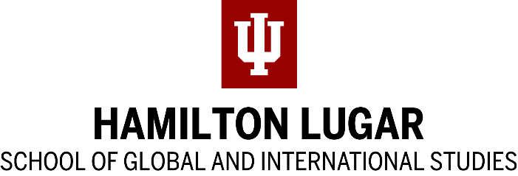

AABS Scholarship Instructor Reference Instructions
The Association for the Advancement of Baltic Studies provides scholarships for the summer study of Estonian, Latvian, and Lithuanian.
AABS scholarships are administered through the Indiana University Language Workshop. The Workshop has a limited number of scholarships, awarded on a competitive basis.

Preference goes to applicants with a demonstrated interest in Baltic area studies or language, or applicants with a demonstrated career goal that requires a knowledge of a Baltic language.
For more information, see http://languageworkshop.indiana.edu.
Please upload your recommendation to the Language Workshop Upload Page or mail it to languageworkshop@indiana.edu NO LATER THAN MIDNIGHT EST, JANUARY 27, 2023.
Contact languageworkshop@indiana.edu for confirmation of receipt or for further information.

AABS Scholarship Reference Letter

Applicant name:

Recommender Information
Name: | Email
Title | Phone
Institution | I have known the applicant for

Please describe your relationship to the applicant and describe the applicant’s academic and language-learning ability.
…

Please describe the applicant’s potential to contribute to the field of Baltic Studies and describe the role of the applicant’s proposed language study in the applicant’s academic and professional career. What sets this applicant apart from other applicants?
…

Additional comments (optional):

______________________________________________________________________________
Signature Date

